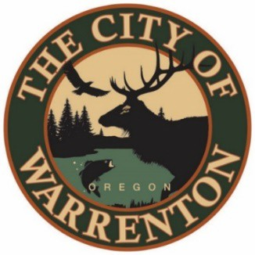

AGENDA

MARINA ADVISORY COMMITTEE
September 18th, 2023 at 2pm
Warrenton City Commission Chambers – 225 S Main Ave
Warrenton, OR 97146

Public Meetings will also be audio and video live streamed. Go to https://www.ci.warrenton.or.us/administration/page/live-stream-public-meetings for connection instructions.

CALL TO ORDER

Welcome New Committee Member William Kerr

PUBLIC COMMENTS

CONSENT CALENDAR

Meeting Minutes May 2023

OLD BUSINESS ITEMS

Adopt A Marina Program Update – Chair Pam Ackley

Update on Completed Projects from FY 2022-2023; Warrenton Pier & Hammond Gangways – Acting Harbor Master Don Beck

Update on Hammond Bank Stabilization Project –Don Beck

NEW BUSINESS ITEMS

Update on completed Dock Improvements from Acting Harbor Master Don Beck

Update on Buoy 10 Revenue – Don Beck

Request for Expressions of Interest (RFEI) Hammond Marina Lease – City Manager Esther Moberg

Update on Dock Assessment and Insurance -Esther Moberg

Update Harbor Master position – Esther Moberg

COMMITTEE COMMENTS

ADJOURNMENT

Warrenton City Hall is accessible to the disabled. An interpreter for the hearing impaired may be requested under the terms of ORS 192.630 by contacting Dawne Shaw, City Recorder at (503) 861-2233 at least 48 hours in advance of the meeting so appropriate assistance can be provided.

